
DS1018
OUTSULATION® MINERAL WOOL SECUROCK® EXOAIR® 430 APPLICATION INSTRUCTIONS
Installation of Outsulation® Mineral Wool Securock® ExoAir® 430 System
TABLE OF CONTENTS
1. GENERAL INSTALLATION REQUIREMENTS 1
2. MATERIALS REQUIRED FOR COMPLETING INSTALLATION OF THE OUTSULATION MINERAL WOOL SECUROCK EXOAIR 430 SYSTEM 4
3. SECUROCK EXOAIR 430 SYSTEM INSTALLATION 5
4. MIXING INSTRUCTIONS 15
5. ACCESSORIES 17
6. INSULATION BOARD INSTALLATION 17
7. INSTALLATION OF REINFORCING MESH AND BASE COAT 21
8. SEALANT JOINT PREPARATION 24
9. DRYVIT PRIMERS 24
10. DRYVIT FINISH 25
11. COATINGS AND SEALERS 26
12. MAINTENANCE AND REPAIR 28

GENERAL INSTALLATION REQUIREMENTS

Project Conditions

Storage of Dryvit Materials

Materials shall be stored at the job site, and at all times, in a cool, dry location, out of direct sunlight, protected from weather and other sources of damage. Minimum storage temperature for Genesis shall be 40ºF (4ºC).

Maximum storage temperature shall not exceed 100ºF (38ºC). NOTE: Minimize exposure of materials to temperatures over 90ºF (32ºC).

Protect all products from inclement weather and direct sunlight.

Storage of Tremco Materials

Keep product from freezing prior to being applied to the substrate.

Materials shall be stored at the job site, and at all times, in a cool dry location, out of direct sunlight, protected from weather and other sources of damage. Storage temperatures shall be 40ºF – 100ºF (4ºC – 38ºC).

Storage of ROCKWOOL® Insulation

The factory packaging is intended for the protection of ROCKWOOL stone wool insulation during shipment and for short term job site storage. It is not intended for protection against the elements during long term outside storage.

For long term storage, ROCKWOOL strongly recommends that the product be stored indoors, in a dry location with the factory packaging removed. If the product is stored outdoors, the factory packaging should be perforated and the product should be protected by a waterproof membrane such as a tarp, that has been properly secured and allowing for ventilation. Product should not be stored in areas that flood, resulting in product storage in standing polluted water. Product should be a minimum of 4 inches (102 mm) above dry ground and kept on a solid flat surface.

For more information: https://www.rockwool.com/syssiteassets/o2-rockwool/documentation/technical- bulletins/commercial/storage-of-rockwool-products---technical-bulletin.pdf.

Storage of Securock ExoAir 430 Materials

All materials shall be delivered in their original unopened packages and stored in an enclosed shelter providing protection from damage and exposure to the elements.

Application General

This document provides the basic and typical instructions for the installation of the Outsulation Mineral Wool Securock ExoAir 430 System to qualify for the Outsulation Mineral Wool Securock ExoAir 430 Warranty. Jobsite specific details require the review and approval of a local Sales Representative or Technical Services.

Application of Dryvit Materials

Application of wet materials shall not take place during inclement weather unless appropriate protection is provided. Protect materials from inclement weather until they are completely dry.

At the time of Dryvit Genesis application, the air and wall surface temperatures shall be from 40ºF (4ºC) minimum to 100ºF (38ºC) maximum.

These temperatures shall be maintained with adequate air ventilation and circulation for a minimum of 24 hours thereafter, or until the products are completely dry. Refer to published product data sheets for more specific information.

Application of Tremco Materials

When applying to surfaces below 40ºF (4ºC), please refer to the Technical Bulletin – Cold Temperature Recommendations for Air Barrier Applications at www.tremcosealants.com or contact Tremco Technical Service at 866-209-2404.

Application of Securock ExoAir 430 Materials

This panel shall be installed in accordance with GA-253 Application of Gypsum Sheathing, ASTM C1280 Standard Specification for Application of Exterior Gypsum Panel Products for Use as Sheathing and the requirements of USG and Tremco published literature.

Proper detailing of joints must be completed before the Outsulation Mineral Wool Securock ExoAir 430 system is installed or 12 months after the date of installation of the panels or whichever comes first.

Ensure substrates are clean, dry and free of dust or debris that could prevent adhesion of sealant.

Securock ExoAir 430 is not approved for use as a nail base.

Details and requirements pertaining to framing and application limitations shall be controlled by the Outsulation Mineral Wool Securock ExoAir 430, structural or fire-resistant-rated systems, and must be approved by the design professional of record.

Always wear appropriate personal protective equipment when handling and installing glass mat panels, such as gloves, safety glasses, hearing protection and a NIOSH-approved dust mask.

Roofing systems shall be capped and sealed, or top of walls protected, in such a way as to eliminate the ability of water to saturate the wall or interior space, both before and after, air barrier system installation. Coordinate installation of Securock ExoAir 430 System with the roofing trade to ensure compatibility and continuity with the roofing system.

Flashing at System Terminations

General

Ensure that flashing is installed in accordance with applicable code requirements and the contract documents. As a minimum, opening preparation is required as shown in the Outsulation Mineral Wool Securock ExoAir 430 System Installation Details, DS1016.

Transition at Roof Lines

Ensure the roof has positive drainage, i.e., all runoff shall be directed to the exterior and away from the structure.

Roof flashing (by others) shall be installed in accordance with industry guidelines, manufacturer’s instructions and contract documents.

Runoff diverters (i.e., kickouts, crickets and saddles) (by others) shall be installed in accordance with industry guidelines, manufacturer's instructions and contract documents. Particular attention must be paid to the eaves/chimney intersections and sloped roof/wall intersections. Refer to the Outsulation Mineral Wool Securock ExoAir 430 System Installation Details, DS1016.

Hold system a minimum of 8 in (203 mm) above flat roofs; 2 in (51 mm) above sloped roofs and paved surfaces.

Openings

Heads, jambs and sills of all openings shall be prepared as described in Section 3.8. For proper application, refer to the Dryvit Outsulation Mineral Wool Securock ExoAir 430 System Installation Details, DS1016.

Continuous flashing at heads of openings as indicated in contract documents. NOTE: For windows or doors that do not have integral flashing, a field-applied flashing shall be installed (by others) in accordance with industry guidelines, manufacturer's instructions and contract documents. Refer to the Dryvit Outsulation Mineral Wool Securock ExoAir 430 System Installation Details, DS1016.

Individual windows that are ganged to make multiple units require the heads to be continuously flashed and the joints between the units to be fully sealed.

Decks and Patio

Wood decks shall be properly flashed prior to system application. See the Dryvit Outsulation Mineral Wool Securock ExoAir 430 System Installation Details, DS1016.

Verify that the Dryvit system terminates above poured decks, patios, landings, etc. and that they are properly sloped and waterproofed to direct water away from the walls.

Utilities

Provisions must be made to ensure that the system terminates properly at lighting fixtures, electrical outlets, hose bibs, dryer vents, etc. Refer to Section 3.7. Refer to the Dryvit Outsulation Mineral Wool Securock ExoAir 430 System Installation Details, DS1016 for general information and guidance.

Grade Level Terminations

Hold system a minimum of 6 in (203.2 mm) above finished grade where paved surfaces are not present, and 2 in (51 mm) where paved surfaces are present.

Sealants

Dryvit materials shall be completely dry prior to installation of sealant materials (typically 48 - 72 hours). Humid or cool conditions may require longer drying times.

Sealants and sealant primers are manufactured and supplied by Tremco but may also be supplied by others. Refer to DS920 or DS153 for a list of sealants that have been tested by the sealant manufacturers and found to be compatible with Dryvit products. NOTE: Dryvit will provide a 2-year extension to the warranty term when Tremco sealants are used.
Notify the general contractor and/or architect and/or owner of all discrepancies. Do not proceed until all unsatisfactory conditions have been corrected.

MATERIALS REQUIRED FOR COMPLETING INSTALLATION OF THE OUTSULATION MINERAL WOOL SECUROCK EXOAIR 430 SYSTEM

Materials Supplied by Dryvit

AquaFlash and AquaFlash Mesh

Genesis

Standard Plus Mesh, Intermediate Mesh, Panzer® 15, Panzer 20, and Detail Mesh®

Mesh shall be colored blue for product identification bearing the Dryvit logo.

Dryvit Finishes

Dryvit Coatings and Primers

Materials listed above are those contained or referenced in the Outsulation Mineral Wool Securock ExoAir 430 System Specification, DS1019. Typically, the project specification will identify the specific materials necessary to complete application.

Products Manufactured by USG / Tremco

Securock ExoAir 430 – A coated fiberglass mat gypsum sheathing with an integral air and water resistive barrier.

Dymonic® 100 – A high-performance, medium-modulus, low-VOC, UV stable, non-sag polyurethane sealant that can be used for detailing fasteners, board joints, around penetrations, as angle beads in transition areas, in control/expansion joints with break metal, for terminating ExoAir® 110AT, and under all the Vulkem Coating Systems and TREMproof Waterproofing Membranes.

ExoAir® DualFlash – A gun and roller-grade liquid-applied flashing membrane. Used in substrate preparation, treating sheathing board joints and inside/outside corners, sheathing fastener heads, preparing rough openings and penetrations, material transitions, flashing integration, and roof tie-ins. ExoAir DualFlash skins and cures quickly, allowing for expedited construction timelines. ExoAir DualFlash can be installed in ambient air and substrate surface temperatures of 20°F (-6°C) and rising.

Note: ExoAir DualFlash can be used instead of Dymonic 100 as shown in the System Installation Details, DS1016.

Tremco ExoAir® 110AT – An 18-mil composite, impermeable membrane that is comprised of 12 mils of butyl and 6 mills of HDPP facer. Used in limited applications as a membrane flashing that will not interfere with the adhesive application of EIFS.

Tremco joint sealants

ExoAir® 230 – A fluid-applied, synthetic, vapor-permeable air barrier designed for use in commercial construction applications.

Materials Supplied by Others

Portland Cement Type I, II or IL

Clean Potable Water

ROCKWOOL Frontrock® Mineral Wool Insulation as manufactured by ROCKWOOL

Mechanical Fasteners and Washer Plates as manufactured by EJOT or Wind-Lock.

SECUROCK EXOAIR 430 SYSTEM INSTALLATION

Framing

Securock ExoAir 430 Panel shall be installed on either wood or steel framing. The framing system shall be sized and designed to meet the requirements of the intended application.

The maximum spacing for framing members is 24" o.c.

Framing shall be straight and true, attached securely following accepted engineering practices and as required for the intended design.

The surfaces to which abutting edges or ends of the panels are to be attached shall not be less than 1¼" for steel framing, and 1½" for wood framing.

Bearing surfaces shall not be less than 5/8" for internal corners or angles.

Framing members shall be installed so the surface will be in an even plane, unless otherwise specified, after the panel(s) has been applied. The fastening surface shall not vary more than 1/8" from the plane of the faces of adjacent framing members.

If wood blocking is desired in steel stud construction for setting windows, doors, etc., position dimensional lumber flush with exterior surface of steel stud and mechanically anchor every 12" o.c. Minimum dimensional size of wood blocking to be nominal 2x4 lumber.

Panel Cutting and Application

Securock ExoAir 430 Panel may be applied with long dimensions parallel or perpendicular to framing members, orange side to exterior. Panel orientation may be governed by local code, or by the requirements of shear or fire rated construction. Consult local codes and site-specific construction documents prior to construction to ensure such requirements are met for every assembly.

Securock ExoAir 430 Panel shall be cut to size by scoring the panel face with a utility knife, or by sawing. Separate by snapping the panel away from the score line to fracture the core, and then by scoring the back mat with a utility knife. If a power saw is used, a cordless, low rpm saw will generate less airborne debris than a corded power saw.

The cut edges and ends of the panel shall be trimmed to obtain neat-fitting joints and flush with framing edges in rough opening if panel is used in rough opening.

Holes for pipe penetrations, fixtures or other small openings shall be scored on the orange face side before removing the cutout with a saw or special tool designed for this purpose.

Where Securock ExoAir 430 Panels meet projecting surfaces, the panel shall be scribed and cut neatly.

All vertical ends and edge joints shall abut over the centers of framing members and shall be offset a minimum of one framing bay between adjacent rows of panels.

Panel joints shall be offset a minimum of 4" from the edge of any opening.

Panels shall be detailed at openings to prevent any water intrusion beyond the membrane of the panel.

Center panel joints on framing members. Fit panels closely at edges and ends but do not force the panels together.

Gaps between boards shall not exceed 1/8". Gaps greater than 1/8" but less than 1/2" shall be filled with Dymonic 100 as fill material prior to detailing board joint as seen in section 8. If gap exceeds 1/2", panel must be repositioned or repaired per repair instructions listed in Section 14 of Securock ExoAir 430 System Application Instructions.

Hold panels in firm contact with framing members and secure with fasteners as specified.

Fasteners shall be driven so the head is seated flush to the membrane of the panel surface without breaking or punching through the surface. Wafer or modified truss head fasteners shall be driven so the underside of the head is flush against the panel surface without breaking or punching through the surface.

Fasteners shall be driven without stripping the fastener or the framing member around the screw shank. Should a fastener miss or strip out of the framing member, DO NOT remove the fastener; an additional fastener shall be properly installed minimum 1" and maximum 2" from damaged area.

Fasteners shall be located not less than 3/8" and not more than 1" from the ends and edges of the panel and shall be placed 8" maximum o.c.

Fasteners can be either bugle or wafer head.

All fastener heads shall be detailed after installation with minimum 1/16" thickness (40 mils) and 3/4" minimum diameter quantity of Dymonic 100 sealant.

Unless superseded by a more stringent specification, the minimum requirements for panel fasteners shall be as follows:
FASTENER SPECIFICATION
ASTM B 117 Head Diameter: 0.325"
Shank: #6
Minimum length: 1 5/8" for wood installations. 1 1/4" for steel installations.

Supplementary use of a panel adhesive to adhere the panel to the framing will strengthen the connection and bridge minor irregularities between the panel and the framing. The use of an adhesive, however, will not reduce the number of fasteners required by the specification. For optimal bond, apply adhesive in accordance with the adhesive manufacturer’s instructions. Care should be taken so excess adhesive does not contaminate board joints. Framing must be free from oil and dirt, and panel must be clean and dry.

Soffit Construction

The roof must be dried in prior to horizontal installation of panels in all soffit applications.

Maximum fastener spacing for soffits is 8" o.c.

Board Joints

In Plane Board Joints

Ensure board joints are in compliance with section III.B.9.

For in plane board joints apply and tool Dymonic 100 sealant ensuring minimum overlap of ¾’’ onto each panel at a 40 mils thickness.

For intersections of vertical and horizontal board joints, caution should be taken to not remove or disturb existing sealant when overlapping.

Feather sealant on horizontal joints out onto panel.
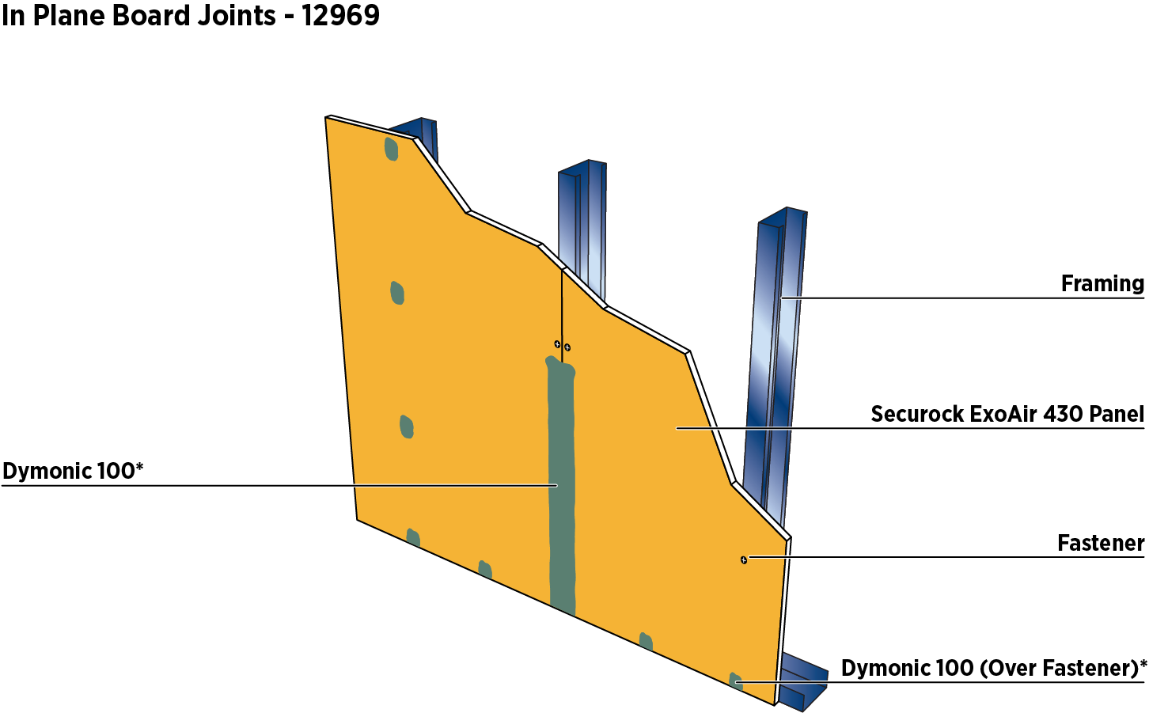
Figure 1: In Plane Board Joints

Corners

Inside Corners

Ensure boards joints are in compliance with section III.B.9.

Install minimum 1/2" wide bond breaker tape centered on joint.

Apply 1/2" bead of Dymonic 100 sealant bead over bond breaker tape.

Tool to achieve cove bead, minimum 1/4" bond beyond edge of bond breaker tape to panel surface on each side of joint.
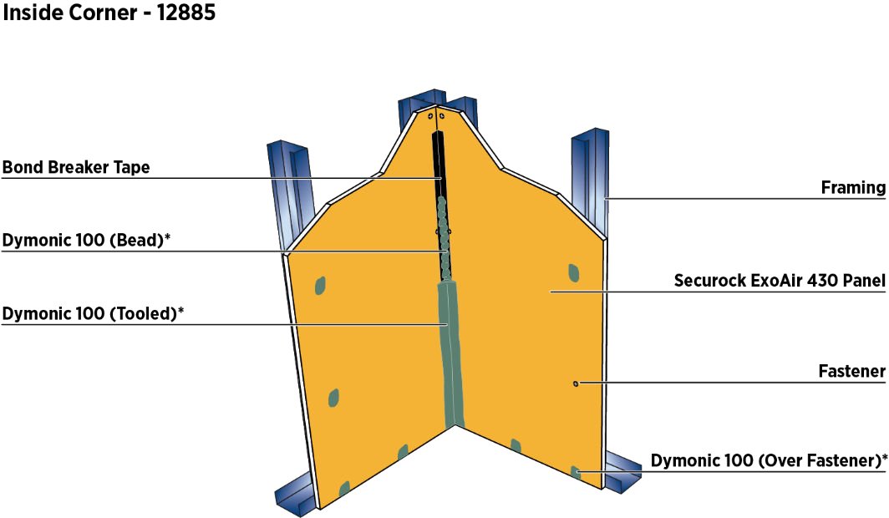
Figure 2: Inside corner

Outside Corners

Ensure boards joints are in compliance with section III.B.9.

Apply a continuous bead of Dymonic 100 sealant in a zigzag pattern or a straight bead on each side of the joint. Tool Dymonic 100 sealant over the corner joint so that sealant grips the Securock ExoAir 430 membrane a minimum of 1" on both sides. Ensure there are no holes or gaps in the sealant and feather it on both sides. Using a mil gauge, ensure that a minimum of 40 wet mils have been applied; if not, reapply sealant to achieve 40 wet mils.
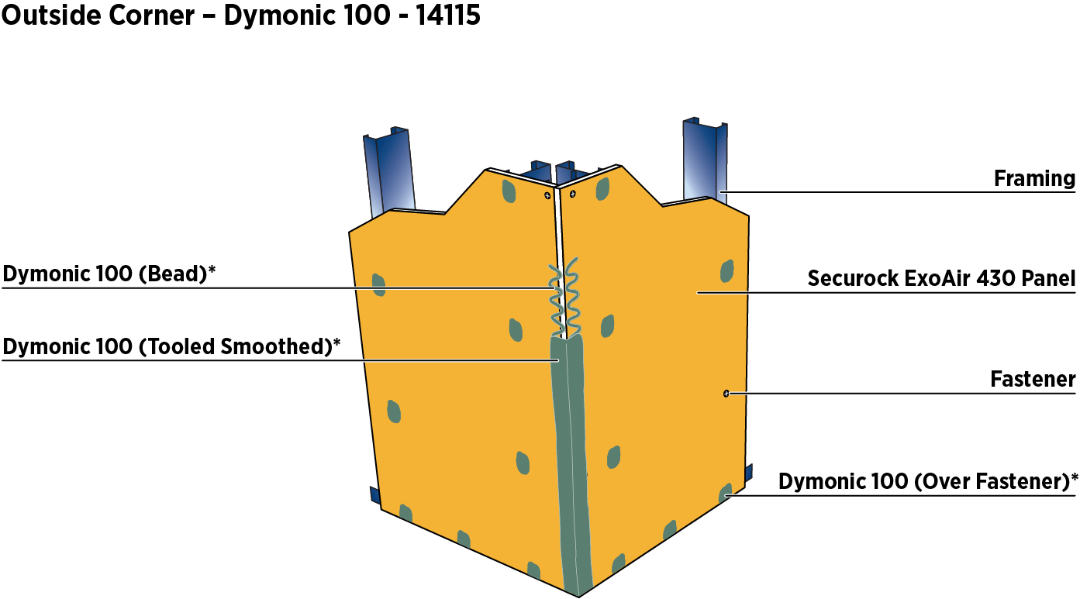
Figure 3: Outside corner

Expansion / Control Joints

The design and placement of control joints is the responsibility of the design professional of record.

Locate all control joints as per cladding system requirements, or in accordance with ASTM C1280 Standard Specification for Application of Gypsum Panel Products for Use as Sheathing, whichever is more stringent.

Proglaze ETA Connections

Friction fit closed cell backer rod flush with the surface of the Securock ExoAir 430 Panel.

Bonding of Proglaze ETA component is achieved with continuous and interconnecting bedding beads of Spectrem 1 silicone sealant. Apply Spectrem 1 to the edges of the Securock ExoAir 430 Panel. Provide 1” wide continuous bedding along edges of the Proglaze ETA adhered to the Securock ExoAir 430 Panel membrane surface and within overlaps of lineals of the Proglaze ETA. Assure that Proglaze ETA is centered over gap and sufficient sealant is applied to achieve the 1” bedding bead. Using a hand-held seam roller, lightly roll press the Proglaze ETA to firmly bed, rolling toward its edge to force some sealant out, creating a slight bleed, and then tool the excess sealant back over the top of the Proglaze ETA.
- Preplan installation to minimize splicing of Proglaze ETA. When splicing is required, provide a minimum 1” overlap of the Proglaze ETA. Installation should begin at bottom of joint following typical construction practices of proper shingle effect of the overlap for vertical joints. For horizontal joints connected to vertical control joints, horizontal joint shall be detailed first then lapping vertical joint over top.
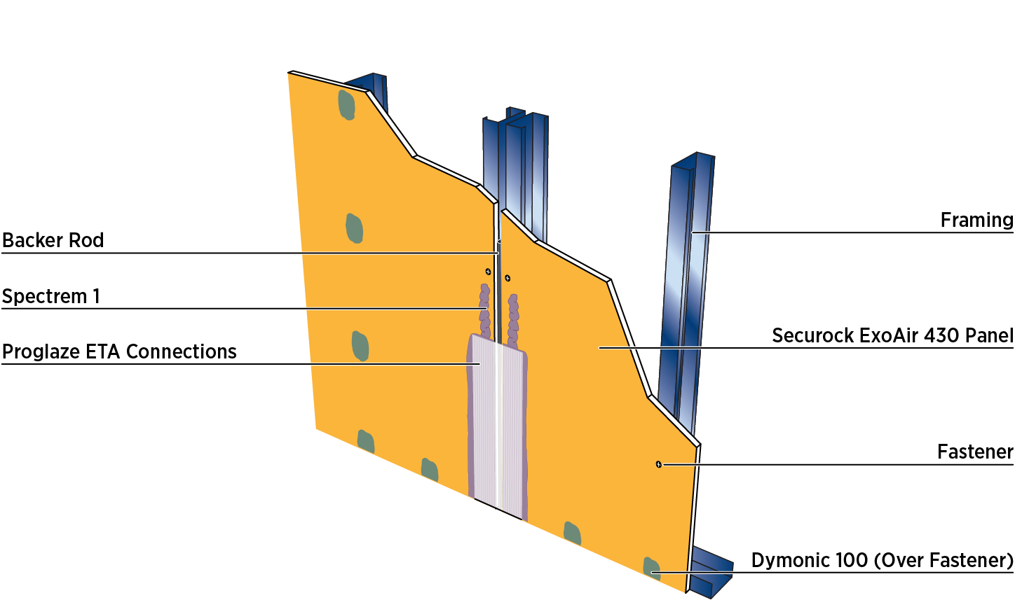
Figure 4: Expansion / Joint Control

Brake Metal and Sealant

Joint to be studded out with panel terminating at outside edge of stud.

Brake metal shall be minimum 26-gauge aluminum or stainless steel with minimum 1" x 1" legs.

On one side of the joint, apply 1/4" bead of Dymonic 100 sealant 1/8" from edge of panel.

Angle brake metal over wet sealant pressing tight to corner and mechanically attached with minimum 1" fasteners every 12" o.c. through face.

Friction fit closed cell backer rod into joint, recess 1/4" to 1/2" from face of panel. Install Dymonic 100 sealant over backer rod. Fill the joint completely with sealant at a proper width-to-depth ratio, and tool flush to ensure intimate contact of sealant with joint walls. For complete installation instructions, download data sheet from tremcosealants.com/products/Dymonic-100.
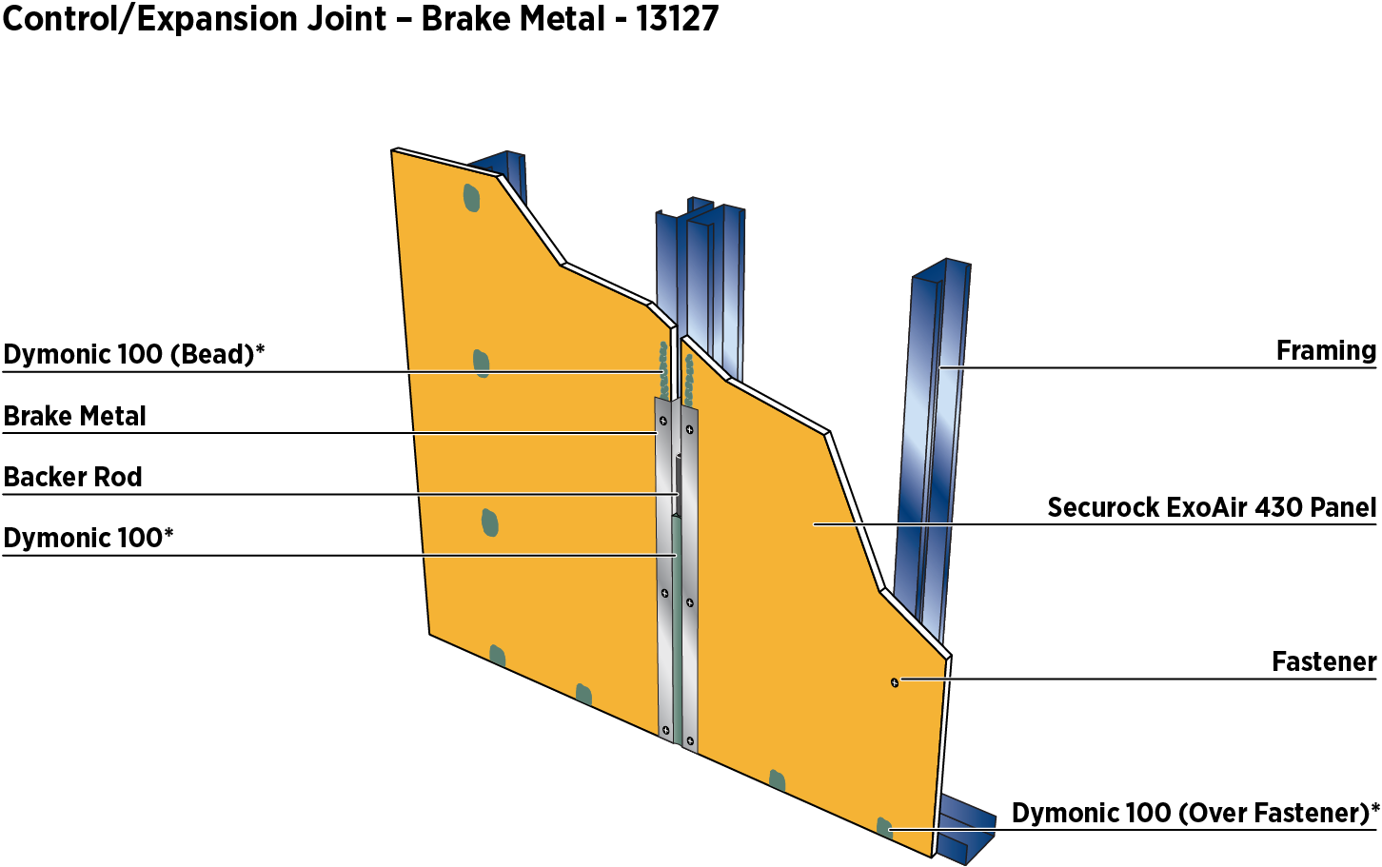
Figure 5: Brake Metal and Sealant

Penetrations

Non-Rated Wall Penetrations

This section is intended to provide guidance for preparing the rough opening for penetrations.

The minimum annular space can be 0", (point contact to maximum 5/8", apply Dymonic 100 sealant).

If annular space exceeds 5/8", fill any gaps with ExoAir LEF or closed cell backer rod flush with the membrane surface of the panel. If necessary, allow LEF to cure and trim flush to the face of the panel.

A cove bead of Dymonic 100 sealant shall be installed that will maintain a minimum 1/4" bond to both the membrane surface and the penetration.
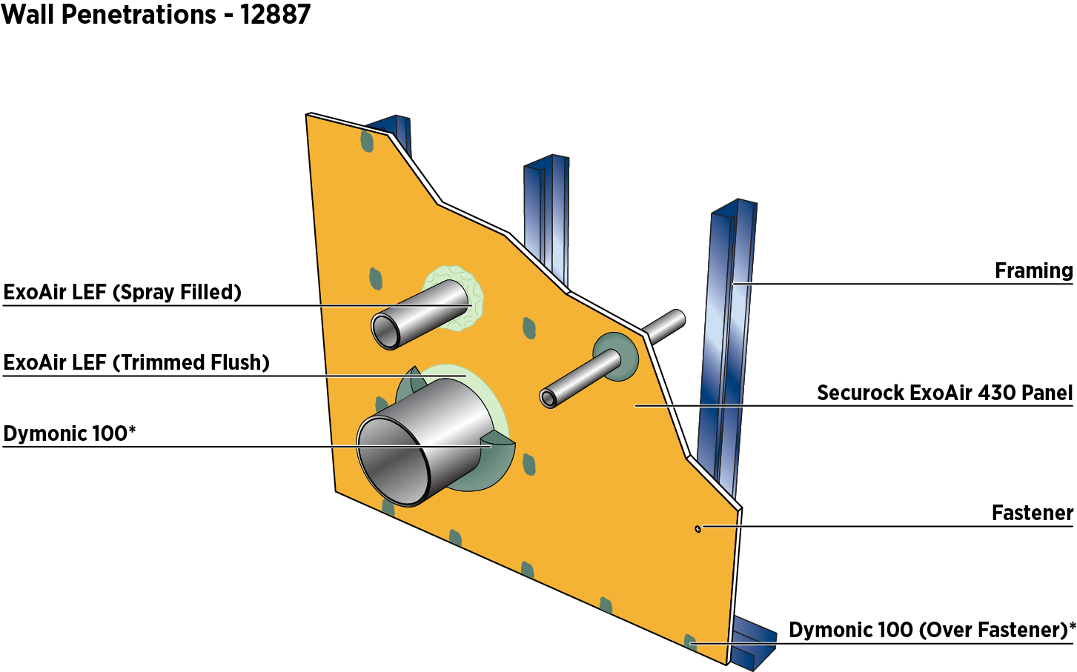
Figure 6: Penetrations

Rough Openings

This section is intended to provide guidance for preparing the rough opening for fenestrations. Consult fenestration manufacturer’s installation instructions for specific installation practices.

Rough Openings – Dymonic 100 Sealant

Apply a continuous bead of Dymonic 100 (sealant in all four corners of the rough opening where the sill, jamb and head meet. Apply a continuous bead of Dymonic 100 sealant in a zigzag pattern or a straight bead around the face of the panel, the sill, jambs and head. Tool Dymonic 100 sealant over the four corners do that sealant grips the Securock ExoAir 430 membrane a minimum of 1’’ on all sides. Ensure there are no holes or gaps in the sealant and feather it out. Using a mil gauge, ensure that a minimum of 40 wet mils have been applied; if not, reapply sealant to achieve 40 wet mils.

In rough opening:

Securock 430 panel – 1’’ minimum

Wood buck – determined by window placement/design professional

Steel framing – determined by window placement/design professional.

Tool Dymonic 100 sealant on the face of the panel toward the rough opening ensuring the exposed core is covered with no holes or gaps. Feather sealant out onto the panel. Tool Dymonic 100 sealant in the rough opening toward the face of the panel ensuring the exposed core is covered with no holes or gaps. Measure sealant to ensure that at least 40 wet mils have been applied; if not reapply Dymonic 100 sealant.

For specific window connections, contact the local Sales Representative or Technical Services.
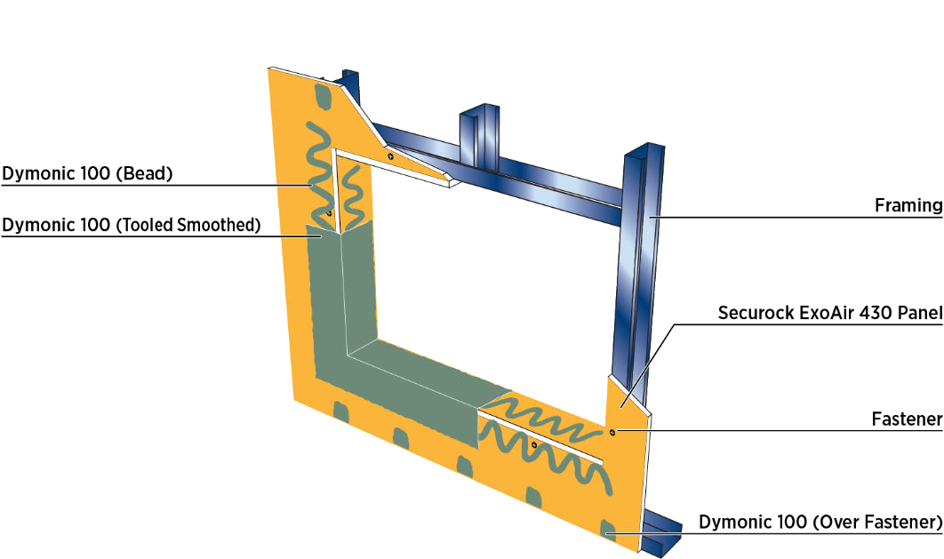
Figure 7: Rough Opening

Nail Flange

Refer to Section 3.8.B.

Immediately prior to installing the flanged window, apply generous bead of Dymonic 100 around the rough opening placed in such a way so that the fasteners penetrate through the wet sealant and fasten to the structure.

Press window into wet sealant and mechanically fasten to structure.

Apply a generous bed of Dymonic 100 sealant completely covering (minimum 1/2" overlap) all fasteners, feathering out beyond the flange onto the panel a minimum of 1/4".

Apply a continuous bead of Dymonic 100 sealant in all four corners of the rough opening where the sill, jamb and head meet. Apply a continuous bead of Dymonic 100 sealant in a zigzag pattern or a straight bead around the face of the panel, the sill, jambs and head. Tool Dymonic 100 sealant over the four corners so that sealant grips the Securock ExoAir 430 membrane a minimum of 1” on all sides. Ensure there are no holes or gaps in the sealant and feather it out. Using a mil gauge, ensure that a minimum of 40 wet mils have been applied; if not, reapply sealant to achieve 40 wet mils.

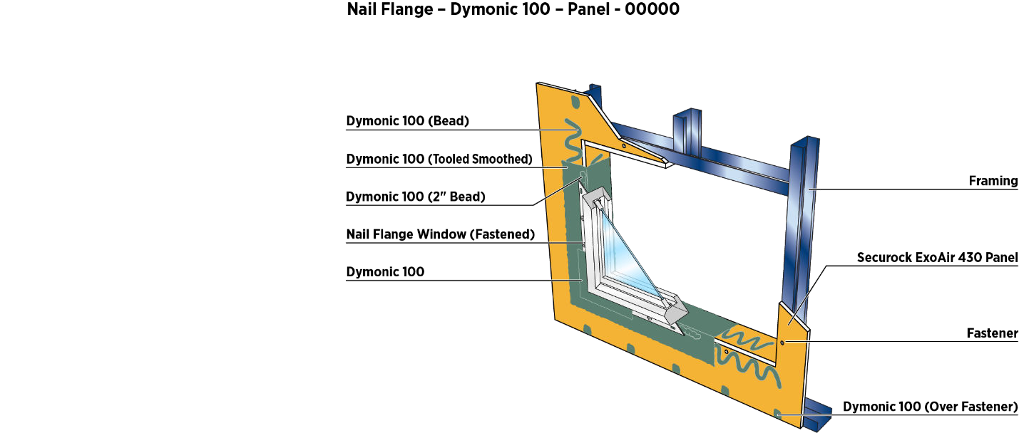
Figure 8: Nail Flange

Transitions

Adjacent Substrates

Dissimilar material connections need to be properly detailed. These steps below are intended to maintain the continuity between the Securock ExoAir 430 panel and dissimilar materials with gaps 1’’ or less. For instruction on gaps with anticipated movement refer to section 13. For joints wider than 1’’ contact Tremco Technical Services.

Fill joint completely with Dymonic 100 sealant and tool flush. Dymonic 100 does not have to cure before applying ExoAir 230.

Apply 70 wet mils of ExoAir 230 and overlapping a minimum 3’’ onto the Securock ExoAir panel. Allow ExoAir 230 to cure. Continue with Tremco field-applied air barrier system.
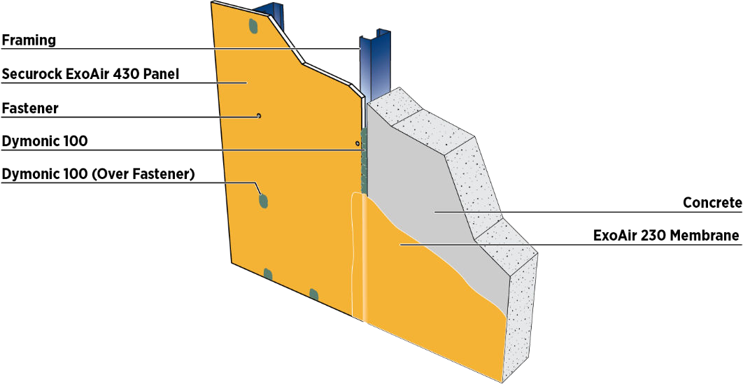
Figure 9: Change in Substrate

MIXING INSTRUCTIONS

General

No additives such as sand, aggregates, rapid binders, anti-freeze, accelerators, etc. shall be added to any Dryvit materials under any circumstances. Such additives will adversely affect the performance of the material and void all warranties.

Genesis

Open the bucket with a utility knife or lid-off.

Due to shipping and storage, there may be some separation of materials. Prior to splitting the material and adding Portland cement, mix the material thoroughly. Use a “Twister” paddle or equivalent mixing blade powered by a 1/2 in (12.7 mm) drill, at 500 - 1200 rpm only. NOTE: A minimum 7 amp drill works best for Portland cement based materials. CAUTION: Do not over-mix or use other types of mixing blades as air entrapment and product damage may occur and result in workability and performance problems.

Pour 1/2 of the freshly mixed material [approximately 30 lbs (13.5 kg)] into a clean plastic container.

Add 1/3 of a bag [approximately 30 lbs (13.5 kg)] of fresh, lump free Type I, II or 1L Portland cement. Either gray or white cement is acceptable. Add cement slowly and mix thoroughly. Do not add large quantities of cement at one time.

Clean potable water may be added to the mixture to adjust the workability.

Add 1 qt (950 ml) of water prior to adding Portland cement. Additional water may be added to adjust workability. Do not over water as this will degrade the performance and promote efflorescence.

Mix the Genesis material with Portland cement thoroughly; then wait ten to fifteen (10-15) minutes and mix again to break the initial set. Retempering with a small amount of water is permissible provided the mixture has not set. The mixture has a pot life similar to other Portland cement plaster material. Mix only as much material as can be conveniently used during a work period.

Finish

Quarzputz®, Quarzputz® E, Sandblast®, Freestyle®, Sandpebble®, Sandpebble® E, Sandpebble® Fine, Sandpebble® Fine E, HDP Finishes, and Weatherlastic® Finishes.

Thoroughly mix the factory-prepared Dryvit finish with a “Twister” paddle or equivalent mixing blade powered by a 1/2 in (12.7 mm) drill, at 450 - 500 rpm, until a uniform, homogeneous consistency is attained. A small amount of clean potable water may be added to adjust workability. Always add the same amount of water to each pail within a given lot to avoid color variation.

NOTE: If using a tint pack to color finish please refer to Tint Pack Mixing Instructions, DS750.

Specialty Finishes

Ameristone

Mix Ameristone for approximately one (1) minute to ensure uniformity using a “Twister” paddle or equivalent mixing blade powered by a 1/2 in (12.7 mm) drill, at 450 - 500 rpm, just prior to application. DO NOT OVERMIX. Mix all pails for the same amount of time. If clean potable water is added as described in DS142 for various application techniques, the same amount must be added to each pail.

Stone Mist®

Mix Stone Mist for one (1) minute to ensure uniformity using a “Twister” paddle or equivalent mixing blade, powered by a 1/2 in (12.7 mm) drill, 450 - 500 rpm, just prior to application. DO NOT OVERMIX.

TerraNeo

Mix TerraNeo for one (1) minute just prior to application, to ensure uniformity using a “Twister” paddle or equivalent mixing blade, powered by a 1/2 in (12.7 mm) drill, at 450 - 500 rpm. DO NOT OVERMIX.

Lymestone

Mix Lymestone with a “Twister” paddle or equivalent mixing blade, powered by a 1/2 in (12.7 mm) drill, at 450 – 500 rpm until a uniform workable consistency is attained. NOTE: If using a tint pack to color finish please refer to Tint Pack Mixing Instructions, DS750.

Custom Brick Finishes

For Custom Brick finishes, refer to Dryvit Custom Brick Application Instructions, DS154, for complete mixing instructions. NOTE: If using a tint pack to color finish please refer to Tint Pack Mixing Instructions, DS750.

Reflectit™

Refer to Reflectit Data Sheet DS705 and Application Instructions DS124 for complete instructions.

Finesse™

Mix Finesse with a “Twister” paddle or equivalent mixing blade, powered by a 1/2 in (12.7 mm) drill, at 450 – 500 rpm until a uniform workable consistency is attained.

Primers

Color Prime™, Color Prime - W™, Primer with Sand™, and Weatherprime®

Mix material with a “Twister” paddle or equivalent mixing blade, powered by a 1/2 in (12.7 mm) drill, at 450 – 500 rpm to a homogeneous consistency.

Coatings and Sealers

Demandit Smooth and Demandit Sanded, HDP Water-Repellent Coating, and Weatherlastic® Smooth

Mix material with a “Twister” paddle or equivalent mixing blade, powered by a 1/2 in (12.7 mm) drill, at 450 – 500 rpm to a homogeneous consistency.

Tuscan Glaze™

Mix Tuscan Glaze with a “Twister” paddle or equivalent mixing blade, powered by a 1/2 in (12.7 mm) drill, at 450 - 500 rpm to a homogeneous consistency, immediately prior to application. As an alternate, boxing of buckets is acceptable. Continuously agitate throughout application to ensure color consistency.

SealClear™

Stir material thoroughly before using and stir often during the application process. As an alternate, boxing of buckets is acceptable.

INSULATION BOARD INSTALLATION

System Terminations

Attach Detail Mesh around the perimeter of all openings, penetrations, and other system terminations by stapling or applying a ribbon of adhesive mixture on the substrate and embedding the Detail Mesh into the wet mixture.

Position the Detail Mesh so that a minimum of 2 1/2 in (64 mm) will extend onto the face of the insulation board. Keep the mesh, which is not embedded, clean.

Inspection of the Insulation Board

Prior to installing the insulation board, it shall be checked to ensure that:

It is ROCKWOOL Frontrock® Insulation Board and shall be obtained from Dryvit or its authorized distributors.

The insulation board pieces shall be delivered in 2 ft (0.6 m) widths by 4 ft (1.2 m) lengths with a minimum thickness of 1.5 in (38 mm) for the ROCKWOOL Frontrock® Mono-Density board, or 2.5 in (63.5 mm) for the ROCKWOOL Frontrock® Mineral Wool Dual-Density Board.

The insulation board complies with ASTM C612 Type IVA.

Any damaged ROCKWOOL Frontrock® Mineral Wool insulation boards should be replaced prior to installation.

Trim edges of boards with serrated insulation knife or sharp trowel to fit substrate.

Methods of Applying the Dryvit Adhesive

Mix the Dryvit adhesive, Genesis, in accordance with Section 4.2.

Notched Trowel Method

With a notched trowel, 3/8 in (9.5 mm) wide, 1/2 in (12.7 mm) deep notches spaced 1 1/2 in (38 mm) apart, apply the adhesive mixture to the backside of the insulation board. Holding the trowel at a 45° angle, apply firm pressure to the insulation board in order to scrape the excess adhesive from between the adhesive beads. NOTE: Apply the adhesive so that the ribbons run vertically when the insulation board is placed on the wall.

Insulation Board Installation

Prior to installing the insulation board, ensure that the surface of the sheathing is clean, dry and free of any foreign materials that may affect adhesion of the insulation board.

Use an 8 in (203 mm) high by 4 ft (1.2 m) long piece of insulation board as a starter row at the base of the wall. This will help minimize the insulation board joints from coinciding with the sheathing joints. Offset the insulation board joints from the sheathing joints a minimum of 8 in (203 mm) in both vertical and horizontal directions. Install the insulation boards with their long edges oriented horizontally.

Apply the adhesive to the insulation board as described in Section 6.3.

Butter the edge of the insulation board at all terminations in order to properly embed the previously installed Detail Mesh used for back wrapping. Back wrapping is necessary to provide appropriate fire performance and to create the proper surface for application of sealant. NOTE: The application of the adhesive mixture to the edge of the insulation board is only done when wrapping with the Detail Mesh.

Allow vertical ribbons of adhesive to sufficiently dry/harden to resist flattening, disruption of bond formation and disruption of drainage cavities behind the mineral wool insulation boards, prior to installation of mechanical fasteners (12-24 hours). Mechanical Fasteners may be initially installed to support the insulation board while the adhesive cures and then permanently installed.

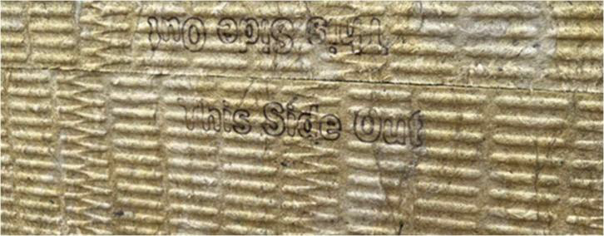
When dual density insulation is used, ensure that the high-density side faces outward as identified by the branding “This Side Out” – Figure 10.
Figure 10

Position the insulation board horizontally on the substrate. Press the board gently to the substrate and slide it into position. Apply firm pressure over the entire surface of the insulation board to ensure uniform contact and high initial grab.

Using a margin trowel, clean the insulation board edges of any adhesive mixture. Ensure that the insulation board joints are butted tightly, and faces are level and flush. CAUTION: Do not allow adhesive to remain in board joints.

In-field backwrapping

Butter the edge of the insulation board at all terminations in order to properly embed the previously installed Detail Mesh used for back wrapping. Back wrapping is necessary to provide appropriate fire performance and to create the proper surface for application of sealant. NOTE: The application of the adhesive mixture to the edge of the insulation board is only done when wrapping with the Detail Mesh.

Mechanical Fasteners

CAUTION: DO NOT BACK-OUT, REMOVE AND/OR RELOCATE FASTENERS leaving open penetrations through the underlying air/water-resistive barrier/substrate. Fasteners must be installed into stud framing or light gauge strapping beyond. If light gauge strapping is used, thickness must match that of studs.

Install fasteners per Outsulation Mineral Wool Securock ExoAir 430 System Installation Details, DS1016. Fasteners along outside corners and other system terminations shall be spaced not more than 8 in (203 mm) apart. Fasteners shall be either surface flush or countersunk based on insulation thickness, underlying wall assembly/substrate type and tested negative wind load results listed in DS1016. Select screw fastener type and coordinate for length and penetration into wall assembly/substrate based on specific project requirements. Combine with Washer Plate type as required or indicated. Fasteners must all be installed prior to the reinforcing mesh and base coat. NOTE: Do not overdrive the fasteners or have them projecting above the surface of the insulation board.

Install subsequent rows of insulation board in a running bond pattern (vertical joints staggered).

With factory edges exposed, stagger vertical joints at inside and outside corners. Make sure the corners are straight and plumb.

If for any reason the insulation board joints are not butted tightly, ALL GAPS GREATER THAN 1/16 in (1.6 mm) MUST BE SLIVERED.

Windows, Doors, Mechanical Equipment and Wall Penetrations:

At openings, align the insulation boards so that the edges (vertical and horizontal joints) do not coincide with the corners of the opening (refer to Dryvit Outsulation Mineral Wool Securock ExoAir 430 System Installation Details, DS1016.

Attach Detail Mesh around the perimeter of the opening as described in Section 6.1.

Hold the insulation board back ¾” from the window/door frame or mechanical equipment to allow for differential movement, proper system edge preparation, and sealant installation as shown in the Dryvit Outsulation Mineral Wool Securock ExoAir 430 System Installation Details, DS1016.

Expansion Joints:

Expansion joints are recommended every 30 ft in this system.

Attach Detail Mesh around the perimeter of the opening as described in Section 6.1.

When abutting dissimilar materials, leave a minimum 3/4 in (19 mm) separation between the insulation board and abutting material to allow for differential movement, proper system edge preparation and sealant installation.

When the Outsulation Mineral Wool System is installed at a substrate transition, leave a minimum 3/4 in (19 mm) separation between the insulation boards to allow for differential movement, proper system edge preparation and sealant installation.

All Detail Mesh that was previously installed for back wrapping the insulation board shall be embedded in the base material mixture at this time.

With a stainless steel trowel, apply Genesis material mixture to the face (and edge if not previously coated) of the insulation board and embed the Detail Mesh in the wet mixture.

Aesthetic Reveals

To install an aesthetic reveal, snap a straight line using a chalk line to mark the position.

Position a straight edge such as a steel stud or track against the insulation board in the proper location to guide the appropriate cutting tool). CAUTION: The thickness of the insulation board at the base of the reveal must not be less than 1.5 in (19 mm).

Use Detail Mesh to ensure continuity of reinforcing mesh through aesthetic reveals continuing a minimum of 2 1/2 in (64 mm) on each side of the reveal.

Apply the base material mixture in the reveal and on the adjacent insulation board surfaces.

Embed the Detail Mesh into base coat mixture on one side of the reveal only.

Use a sled or special tool configured to the profile of the reveal. Embed the Detail Mesh into the base coat mixture through the reveal being careful not to cut the mesh.

Embed the Detail Mesh into the base coat mixture on the other side of the reveal. Ensure that the mesh is fully embedded and that all excess material is removed from the reveal.

Using a damp brush, smooth out any irregularities in the base coat.

CAUTION: If the mesh is cut in the reveal, a new piece of mesh must be installed over the cut.

Where Corner Mesh is specified for additional impact resistance at outside corners, the Corner Mesh shall be embedded in the base coat mixture and allowed to set prior to installing the overall reinforced base coat over the face of the wall.

Corners of all openings such as windows, doors, mechanical equipment and all penetrations shall be
reinforced with Detail Mesh placed diagonally to the opening as illustrated in Figure 11.

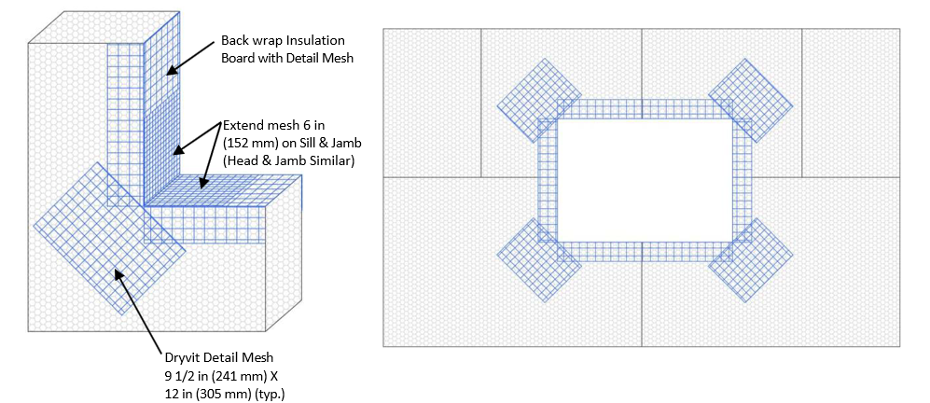
Figure 11

In Field Starter Boards should be fabricated in accordance with the details shown in DS1016.

Refer to DS1016 detail OMW SE430 7 for pre-fabricated starter board geometry, vent location, and installation. 1/2-inch masking tape may be used to temporarily cover reinforcing mesh where vent opening is illustrated. When using the double-pass method for base coat installation (see section 7.5.A.3.a on the following page), do not install base coat at the vent location on the first pass. Install masking tape over the vent location prior to the second pass. Once the base coat is installed, remove the masking tape to clear base coat from the vent opening while base coat is still wet.

INSTALLATION OF REINFORCING MESH AND BASE COAT

General

Do not apply the Dryvit materials in the rain. The insulation board must be dry prior to applying the base coat material.

Prior to installing the reinforced base coat, inspect the surface of the insulation board for:

Flatness: Use a minimum 8 ft (2.4 m) straight edge to check for flatness.

Damage and foreign materials: correct deficiencies as necessary.

The face of the ROCKWOOL Frontrock® Mineral Wool insulation board is not to be shaved or rasped but instead use base coat to level the substrate as required.

Hollow areas may be filled with up to 1/8” maximum of base coat.

Mix the Genesis base coat material as described in Section 4.2.

Prior to Installing the reinforcing Mesh, it Should be Inspected to ensure that it has been Furnished by Dryvit

Dryvit reinforcing mesh is available in the following widths and lengths:

Standard Plus, and Intermediate - 48 in x 150 ft (1.2 m x 45.7 m)

Panzer 15 - 48 in x 75 ft (1.2 m x 22.9 m)

Panzer 20 - 48 in x 75 ft (1.2 m x 22.9 m)

Corner - 9 1/4 in x 150 ft (235 mm x 45.7 m)

Detail - 9 1/2 in x 150 ft (241 mm x 45.7 m)

It shall be colored blue for product identification bearing the Dryvit logo.

Corner bead accessory, by others, where detailed or specified.

Where Specified or Required Dryflex May only be Used as a Skim Coating at Grade or Sloped Surfaces

Allow the Dryflex to cure a minimum of 24 hours or until dry.

Color variation may occur between Dryflex and Genesis Base Coat areas. The use of Color Prime is recommended where this condition occurs.

Base Coat Application

Standard Base Coat (single layer of Standard Plus or Intermediate Reinforcing Mesh)

Spot all fastener heads with Genesis mixture base material so they are flush with the surrounding insulation board surface, and allow to set until firm to the touch.

The base coat shall be applied using the double pass method such that the reinforcing mesh is fully embedded, and the Genesis mixture applied at the recommended coverage of 120 sf/ pail (11.1m²).

Double pass method

Using a stainless steel trowel, apply the base coat mixture on the entire surface of the insulation board to an area slightly larger than the width and length of a piece of reinforcing mesh, in a uniform thickness of approximately 1/8 in (3.2 mm) to 3/16 in (4.7 mm). NOTE: The reinforcing mesh may be installed either vertically or horizontally.

Immediately place the reinforcing mesh against the wet base coat mixture. With the curve of the mesh against the wall, trowel from the center to the edges avoiding
wrinkles, until the mesh is fully embedded and not visible. Trowel smooth to a uniform
thickness. NOTE: The reinforcing mesh shall be continuous at corners and mesh edges lapped not less than 2 1/2 in (64 mm). Do not lap the reinforcing mesh within 8 in (203 mm) of a corner.

Allow the base coat mixture to set up until firm to the touch. Trowel a second coat of the base coat mixture over the first coat to fully cover the reinforcing mesh – Figure 12. The result should be such that the reinforcing mesh is embedded in the middle of the base coat by thickness and the total thickness of the base coat does not exceed 3/16”. Do not allow the first pass to completely dry prior to the second pass application or an excessive amount of base coat mixture will be necessary to fully coat the wall surface.

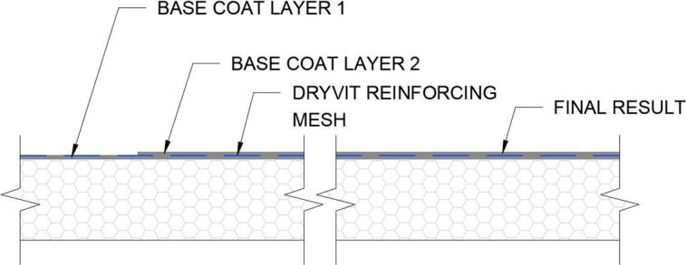

Figure 12

Protect completed work from water penetration and runoff.

Allow the base coat to cure a minimum of 24 hours before proceeding with application of finish coat. Cool, damp conditions may require longer drying times. Do not apply finish to a wet or damp base coat.

Panzer Mesh Base Coat (Panzer 15 or Panzer 20 used in conjunction with Standard Plus Reinforcing Mesh). Panzer Mesh is recommended for use at all ground floor locations and at high traffic areas. Refer to contract documents.

Spot all fastener heads with Genesis mixture base material so they are flush with the surrounding insulation board surface and allow to set until firm to the touch.

Using a stainless steel trowel, apply the base coat mixture on the entire surface of the insulation board to an area slightly larger than the width and length of a piece of reinforcing mesh, in a uniform thickness of approximately 1/8 in (3.2 mm).

Immediately place the reinforcing mesh against the wet base coat mixture. With the curve of the mesh against the wall, trowel from the center to the edges avoiding wrinkles until the mesh is fully covered and not visible.

Continue in the same manner until the entire area requiring Panzer Mesh is covered. CAUTION: Do not lap the Panzer Mesh. Adjacent pieces are to be tightly butted.

Protect completed work from water penetration and runoff.

Allow the Panzer base coat to cure a minimum of 24 hours prior to applying Dryvit's Standard Plus Reinforcing Mesh.

Apply the second layer of reinforcing mesh in accordance with Section 7.5.B. Offset the edges of the Standard Plus Reinforcing Mesh from the edges of the Panzer Mesh a minimum of 8 in (203 mm). Tip: If Panzer Mesh is installed horizontally, we recommend the Standard Plus Mesh be installed vertically and vice versa.

SEALANT JOINT

PREPARATION

All Outsulation Mineral Wool Base Coat Surfaces Which will be in Contact with Sealant must be Coated with Either Color Prime or Demandit Smooth in the Event Sealant is to be Adhered to the EIFS System Base Coat Surface. Refer to Dryvit Document DS153.

DRYVIT PRIMERS

APPLICATION

Prior to applying the Dryvit primers, the base coat shall have cured a minimum of 24 hours and shall be dry and hard. Cure time may be longer depending on environmental conditions. NOTE: Refer to Product Data Sheets when applying over other materials.

Inspect the base coat for any irregularities such as trowel marks, board lines, rough corners and edges, improper reinforcing mesh embedment as well as efflorescence. NOTE: Correct all irregularities and remove all efflorescence prior to applying the Dryvit primer.

Mix Dryvit Primers to a smooth homogeneous consistency in accordance with Section 4.5.

DRYVIT FINISH

APPLICATION

Prior to applying the Dryvit finish, the base coat shall have cured a minimum of 24 hours and shall be dry and hard. Cure time may be longer depending on environmental conditions.

Inspect the base coat for any irregularities such as trowel marks, board lines, rough corners and edges, improper reinforcing mesh embedment as well as efflorescence. NOTE: Correct all irregularities and remove all efflorescence prior to applying the Dryvit finish.

General

Important: All Dryvit finishes must be installed continuously to a natural break such as corners, expansion joints, or tapeline. Mechanics must maintain a wet edge. Whenever possible, order enough material in a single batch to complete the project to avoid potential color variations from batch to batch. Sufficient personnel and scaffolding must be provided to continuously finish a distinct wall area or otherwise cold joints will result. Scaffolding must be spaced a minimum of 18 in (458 mm) from the wall to prevent staging lines. On hot windy days, the wall may be fogged with clean potable water to cool the wall and facilitate finish installation. As with other plaster materials, installation work should precede the sun. For example, work the shady or cool side of the building. If this is not possible, scaffold should be shaded with a tarp or nursery shade cloth. Do not introduce water to the finish material once it is installed on the wall. This will cause color variations. Each mechanic must use the same tool and hand motion and match the texture of the mechanics above, below and on each side. Use finish from a single batch number whenever possible.

Do not apply Dryvit materials in the rain. The base coat must be dry prior to applying the Dryvit finish or coatings.

Do not apply textured Dryvit finish material in sealant joints.

Application

Mix the Dryvit finishes as described in Sections 4.3.

Quarzputz, Quarzputz E, Sandblast, Weatherlastic Quarzputz

Using a clean stainless steel trowel, apply a coat of the Dryvit finish in a uniform thickness on the dry base coat. NOTE: The Dryvit Quarzputz finish shall be applied and leveled to a uniform thickness no greater than the largest aggregate. The Sandblast finish is applied and leveled to a thickness of approximately 1 1/2 times the largest aggregate.

The texture is achieved by uniform hand motion and/or tool that produces the texture to match the approved sample. Each mechanic must use the same tool and hand motion to ensure that the texture achieved is uniform over the entire wall area.

Sandpebble, Sandpebble E, Sandpebble Fine, Sandpebble Fine E, Weatherlastic Sandpebble, Weatherlastic Sandpebble Fine.

Using a clean, stainless steel trowel, apply an even coat of the finish to a thickness slightly thicker than the largest aggregate size.

Pull across using a horizontal trowel motion to develop a uniform thickness no greater than the largest aggregate of the material.

The texture is achieved by a uniform hand floating motion with a clean stainless-steel trowel; wipe the trowel and wet it lightly. Apply light pressure in a circular motion.

Freestyle

Using a clean, stainless steel trowel, apply the Freestyle finish on the base coat in a thickness not greater than 1/16 in (1.6 mm). The texture is either pulled out of this base to a thickness of no greater than 1 /4 in (6.4 mm) or the texture may be achieved by adding more Freestyle finish to the base coat using the same texturing motions that are used with other plaster materials, such as, a skip trowel finish. Numerous other aesthetically pleasing textures can be created to match approved samples. NOTE: The maximum thickness of Freestyle finish texture shall not exceed 1/4 in (6.4 mm).

Weatherlastic Adobe

Using a brush, roller or airless spray equipment, apply a coat of color coordinated Color Prime (see Section 4.5 for mixing instructions) at the recommended coverage to the cured base coat and allow to dry.

Using a stainless steel trowel, apply a coat of Weatherlastic Adobe approximately 1/16 in (1.6 mm) to the wall surface. Allow the Weatherlastic Adobe finish to take-up.

Using a stainless steel trowel, apply a second coat of Weatherlastic Adobe to obtain the desired texture. Tip: An atomizing spray bottle may be used to apply a mist of water to the surface in the finishing step.

Specialty Finishes: Ameristone, DS142; Stone Mist, DS420; TerraNeo, DS481; Custom Brick, DS154; NewBrick, DS871.

Mix the Specialty finishes as described in Section 4.4.

Apply the specialty finishes in accordance with the products’ Application Instructions or Data Sheets listed above.

COATINGS AND SEALERS

Mix coatings and sealers to a smooth homogeneous consistency in accordance with Section 4.6.

Demandit Smooth and Weathercoat

Apply with a brush, roller, or airless spray equipment.

When applying with a roller, a maximum 3/4 in (19 mm) nap, polyester or polyester blend with nylon or lambswool, with beveled ends and a phenolic core is recommended. An 18 in (458 mm) wide roller frame with a 2 1/4 in (57 mm) inside diameter is also recommended.

Apply in one continuous coat, maintaining a wet edge as the application proceeds to a natural break. The roller cover must be kept fully loaded as the application proceeds. CAUTION: Do not stretch out the application by rolling with a dry roller. The last leveling roller strokes should always be in the same direction. Do not cut in around openings prior to overall application, but rather, do the cut-in work as the application proceeds.

Do not allow Demandit Smooth or Weathercoat to dry on roller covers. Roller covers with dried coating do not apply the coating evenly.

Changing color requires the application of two coats.

Demandit Sanded

Apply the Demandit Sanded with a brush or 1/2 in - 5/8 in (12.7 mm – 15.9 mm) nap roller.

Roll or brush in multiple directions and then lightly finish in one direction to ensure that no lap marks remain.

A second coat may be required for heavy textured surfaces or when there is a contrast of colors. Apply the second coat as described in paragraph XIII.B.2 and 3 above. CAUTION: Do not attempt to apply Demandit Sanded in one heavy coat. Two coats are recommended. Apply the second coat only after the first coat is completely dry. Important: Texture changes will exist after Demandit Sanded is applied over existing Dryvit finishes. The degree of change is a function of the thickness and the number of coats of Demandit Sanded.

Weatherlastic Smooth

Apply a minimum 11 mils dry film thickness (22 mils wet film thickness). This is achieved by applying the Weatherlastic Smooth in two (2) 11 mil wet coats. Under average drying conditions, 70 °F (21 °C), 50% RH, two (2) hours drying time between coats should be adequate.

For cutting-in and trim, a nylon bristle brush is recommended.

Roller Application

A minimum 10 in (254 mm) roller cover with a 1 1/4 in - 1 1/2 in (32 mm - 38 mm) nap is recommended.

Completely saturate the roller cover and keep the roller loaded with coating to avoid foaming. Do not dry-roll or over-roll as this will cause excessive entrapment of air within the coating.

A second coat is applied in a similar manner after the first coat has adequately dried.

Spray Application

Application by airless spray equipment or mastic pump and gun allows application of coating at total required application rate with a minimum of stipple or thickness variations.

Equipment should have the capacity to pump 2 gal (7.6 L) of coating per minute.

Material hose should be minimum 1/2 in (12.7 mm) inside diameter for spraying coating through more than a 50 ft (15 m) length. Minimum bursting of 800 lbs (3600 N) is recommended. Tip: Orifice sizes of 0.021 in - 0.032 in (0.53 mm - 0.81 mm) will be required depending on equipment used.

Cross apply coating holding spray gun perpendicular to, and approximately 3 ft (0.91 m) from the wall surface. Avoid excessive material build-up by holding spray gun away from the wall when pulling the trigger, then bringing gun across area to be coated. Maintain a wet edge and avoid starting and stopping in the middle of the wall. Do not attempt to overreach spray pattern as this may result in appearance of irregular spray pattern. Place scaffolding and equipment to facilitate quick application without numerous interruptions.

A 10 % loss from overspray should be anticipated.

Backrolling sprayed areas is recommended to control pin holing on spray applications over porous surfaces.

Tuscan Glaze

Mix Tuscan Glaze to a smooth homogenous consistency in accordance with Section 4.6.B. Continuously agitate throughout application to ensure color consistency.

Tuscan Glaze is best applied on large areas using a Hudson-type sprayer or airless spray equipment. For smaller areas, Tuscan Glaze is best applied with a paint pad or, depending on the desired results, a roller, paint brush or sponge. Job site mock-ups are required and should represent the actual job site application techniques.

Apply Tuscan Glaze evenly in light strokes. If sagging or running occurs, use a sponge or paint pad to correct immediately. Watch for brush or roller lines. If brush or roller lines appear, use a damp sponge, a paint pad or rag to make them disappear before the Tuscan Glaze starts to dry. The wall may be blotted with a camelback sponge to achieve the desired mottled appearance. Check walls throughout the application to ensure that uniformity and the desired appearance is achieved.

SealClear

Mix SealClear to a smooth, homogeneous consistency in accordance with Section 4.6.C.

MAINTENANCE AND REPAIR

Refer to DryvitCARE EIFS Repair Procedures, DS498.

